**Development of Gross Motor Skills through Rhythmic Movement Programs: A Preliminary Concept**

Muhammad Naeimmuddin Zakaria1*, Borhannudin Abdullah2, Shamsulariffin Samsudin3

1 Faculty of Educational Studies, Putra University of Malaysia,

43400, Selangor, Malaysia

email: GS71229@student.upm.edu.my

2Faculty of Educational Studies, Putra University of Malaysia,

43400, Selangor, Malaysia

email : borhannudin@upm.edu.my

3Faculty of Educational Studies, Putra University of Malaysia,

43400, Selangor, Malaysia

email: shamariffin@upm.edu.my

*Corresponding author, email: GS71229@student.upm.edu.my

**Abstract**

Gross motor skills are an important foundation for children's physical, cognitive and psychosocial development. However, the increasing rates of obesity and physical inactivity among Malaysian children have raised concerns about delayed motor development. This study aimed to evaluate the effects of a rhythmic movement program on the development of gross motor skills in primary school students aged 8 to 10 years. A total of 64 students were selected as a sample through stratified sampling for treatment group and control group. A quasi-experimental design involving treatment and control groups was used, with a 10-week intervention and the use of the TGMD-3 test to assess locomotor and manipulative skills. The study also took into account demographic variables such as age, gender, body mass index, physical activity time and socioeconomic status. The results of the study are expected to show an improvement in gross motor skills in the treatment group and provide practical recommendations for the integration of rhythmic movement into the primary school Physical Education curriculum in Malaysia.

## **Keywords: Gross Motor Skills, Rhythmic Movement, Physical Education, Locomotor Skills, Manipulative Skills, Curriculum Development, Motor Development**

## **1. Introduction**

Physical inactivity among children is now a public health issue of growing concern in Malaysia, in line with the increase in sedentary or inactive lifestyles that begin to take root since early childhood. Based on the findings of the National Health and Morbidity Survey (NHMS) 2023, more than 84% of adults in Malaysia are physically inactive, while the obesity rate among children has increased dramatically from 6.1% in 2011 to 11.9% in 2023 (Ministry of Health Malaysia, 2023). These statistics not only indicate the pattern of inactive lifestyles among adults but also reflect the weakness of early intervention on physical behavior among children. This tendency towards inactivity has a direct impact on the development of gross motor skills, which are fundamental components in physical growth, postural control, coordination and movement literacy that are important in students' daily lives and academic achievement (Barnett et al., 2016; Fisher et al., 2005). Previous studies have consistently shown that structured physical activity, especially rhythmic movements such as dance, has a positive influence on various aspects of gross motor development including coordination, balance, strength and postural control. For example, Fitri et al. (2018) reported that a creative locomotor dance intervention led to significant improvements in gross motor skills compared to traditional play. Similarly, Safitri and Nugroho (2017) found a 27.54% increase in gross motor scores among 5- to 6-year-old children following a creative dance program.

**2. Conceptual Framework**

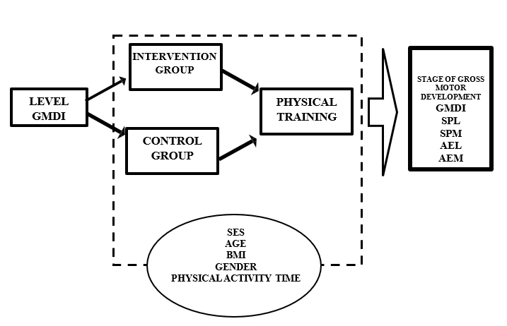

Figure 1: Conceptual framework

The construction of the conceptual framework of this study is based on two main theoretical foundations in motor development, namely the Theory of Motor Development by Gallahue and Ozmun (2012) and the Dynamic Systems Theory by Thelen (1989). Both theories emphasize that gross motor development is not an automatic or linear process, but rather emerges from the dynamic interaction of internal biological factors, external environmental stimuli and accumulated movement experiences. Thelen (1989) suggests that motor patterns are formed through self-organization, influenced by task constraints, physical and cognitive characteristics of the learner and contextual conditions. As a complement, Gallahue and Ozmun (2012) emphasize the importance of intentional movement exposure to strengthen developmental readiness and skill development among children.

**3. Methods**

This study used a quasi-experimental design involving treatment and control groups. The treatment group followed a 10-week rhythmic movement intervention, while the control group continued Physical Education sessions according to the Primary School Standard Curriculum (PSC). The sample consisted of students aged 8 to 10 years old in selected primary schools, selected through stratified sampling based on location, gender, and age. The sample size was determined using Statistical Power Analysis based on Cohen’s Table (1988) to achieve a power of 0.80 at a significance level of .05.

The main instrument was the Test of Gross Motor Development–Third Edition (TGMD-3) by Ulrich (2017). The study was conducted in three phases: pretest, intervention, and posttest. In the pretest phase, all age groups were assessed and the group with the lowest skill level was selected for the intervention. The intervention was implemented twice a week, 35–40 minutes per session, using a structured dance module developed by the researchers. The posttest used the same instrument.

Data were analyzed using the latest version of SPSS. MANOVA was used to assess the effects of the intervention on the locomotor and manipulative domains of the TGMD-3, followed by additional analyses based on moderator variables such as gender, socioeconomic status and BMI, in line with the approach of Cliff et al. (2009) and Hardy et al. (2012). The following is the study design flowchart:

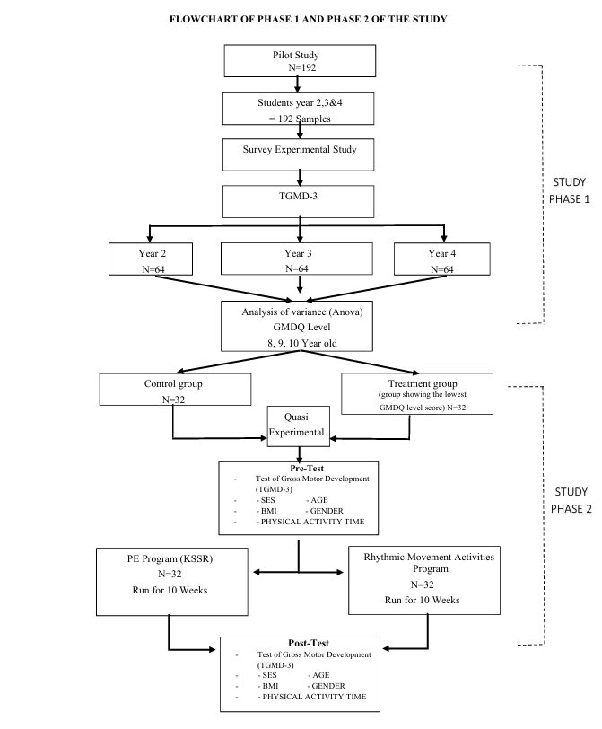

Figure 2: Study Design Flowchart

**4. Expected Results and Discussion**

## This study is expected to show that a planned and contextual rhythmic movement program can improve gross motor skills of primary school students aged 8 to 10 years. The treatment group is expected to record a significant increase in GMDQ scores as well as locomotor and manipulative components compared to the control group that followed conventional Physical Education instruction, consistent with the findings of previous studies (Robinson et al., 2015; Fitri et al., 2018).

## Further analysis is expected to show that moderator variables such as socioeconomic status, gender, age, BMI and time of physical activity influence the rate of skill improvement. For example, students from lower socioeconomic backgrounds are expected to benefit more from planned physical activity at school (Cliff et al., 2009; Hardy et al., 2012).

## In addition to improving motor skills, this intervention has the potential to support socio-emotional development and positive attitudes towards physical activity (Safitri, 2017), in line with the holistic education approach in KSSR that emphasizes cognitive, affective and psychomotor balance. This study is also able to contribute to educational policy by proposing the integration of rhythmic movement modules into the national Physical Education curriculum (Schwender et al., 2018).

## **4. Conclusion**

Overall, this study represents a strategic initiative that aims to address a critical gap in children’s education and health by evaluating the effectiveness of rhythm-based movement programs on gross motor skill development. Through the application of a rigorous quasi-experimental research design and the use of valid and reliable assessment instruments, this study is expected to provide a comprehensive, data-driven understanding of the impact of the intervention. These findings can serve as a basis for the development of large-scale interventions and the strengthening of Physical Education practices that are more meaningful and contextually relevant to the Malaysian educational landscape.

For future research, it is recommended that attention be paid to the long-term effects of the intervention on children’s active behavior, commitment to physical activity, and psychosocial development. In addition, implementation across diverse cultural, geographic, and institutional settings should be explored to determine the scalability and adaptability of the module at the national level (Adolph & Hoch, 2019).

## 

## **References**

1. Abdullah, N., Amri, S., & Kok, L. Y. (2016). Aktiviti fizikal dan pembangunan motor. Jurnal Pendidikan Jasmani Asia Tenggara, 8(2), 45–58.

2. Adolph, K. E., & Hoch, J. E. (2019). Motor development: Embodied, embedded, enculturated, and enabling. Annual Review of Psychology, 70, 141–164.

3. Barnett, L. M., Lai, S. K., Veldman, S. L. C., Hardy, L. L., Cliff, D. P., Morgan, P. J., Zask, A., Lubans, D. R., Shultz, S. P., Ridgers, N. D., & Okely, A. D. (2016). Correlates of gross motor competence in children and adolescents: A systematic review and meta-analysis. Sports Medicine, 46(11), 1663–1688.

4. Cliff, D. P., Okely, A. D., Smith, L. M., & McKeen, K. (2009). Relationships between fundamental movement skills and objectively measured physical activity in preschool children. Pediatric Exercise Science, 21(2), 266–280.

5. Faber, I. R. (2016). The relationship between motor skills and academic performance in children: A systematic review. European Journal of Physical Education and Sport Science, 2(5), 1–12.

6. Fisher, A., Reilly, J. J., Kelly, L. A., Montgomery, C., Williamson, A., Paton, J. Y., & Grant, S. (2005). Fundamental movement skills and habitual physical activity in young children. Medicine & Science in Sports & Exercise, 37(4), 684–688.

7. Fitri, M., Sultoni, K., Jajat, J., & Lasrina, O. (2018). Effect of locomotor creative dance on student motor skills development. In Proceedings of the 2nd International Conference on Sport Science, Health and Physical Education (ICSSHPE 2017) (Vol. 2, pp. 241–244).

8. Gallahue, D. L., & Ozmun, J. C. (2012). Understanding motor development: Infants, children, adolescents, adults (7th ed.). McGraw-Hill.

9. Gibson, J. J. (1979). The ecological approach to visual perception. Houghton Mifflin.

10. Hardy, L. L., King, L., Farrell, L., Macniven, R., & Howlett, S. (2012). Fundamental movement skills among Australian preschool children. Journal of Science and Medicine in Sport, 13(5), 503–508.

11. Haywood, K. M., & Getchell, N. (2005). Life span motor development (4th ed.). Human Kinetics.

12. Lykesas, G., Tsapakidou, A., & Tsompanaki, E. (2014). Creative dance as a means of growth and development of motor skills for elementary school children. Asian Journal of Humanities and Social

13. Raghupathy, M. K., Divya, M., & Karthikbabu, S. (2021). Effects of traditional Indian dance on motor skills and balance in children with Down syndrome. Journal of Motor Behavior, 53(4), 1–9.

14. Robinson, L. E., Stodden, D. F., Barnett, L. M., Lopes, V. P., Logan, S. W., Rodrigues, L. P., & D'Hondt, E. (2015). Motor competence and its effect on positive developmental trajectories of health. Sports Medicine, 45(9), 1273–1284.

15. Safitri, N., & Nugroho, R. (2017). Stimulation dance creations art on gross motor development children aged 5–6 years in Islamic Al-Huda TK Semarang. Indonesian Journal of Early Childhood Education Studies, 6(1), 39–42.

16. Schwender, D., Spengler, S., Oedl, C., & Mess, F. (2018). Effects of dance interventions on aspects of the participants’ self: A systematic review. Frontiers in Psychology, 9, 1130.

17. Thelen, E. (1989). Self-organization in developmental processes: Can systems approaches work? In M. Gunnar & E. Thelen (Eds.), Systems and development (Vol. 22, pp. 77–117). Erlbaum.

18. Ulrich, D. A. (2017). Test of Gross Motor Development–Third Edition (TGMD-3). Pro-Ed.

19. Utami, F. B., Elnawati, & Musa, M. Z. (2023). The influence of dancing activities on children’s gross motor skills at TK Aisyiyah Cikole Sukabumi. Jurnal SIBATIK, 2(11), 1098–1107.

20. Venetsanou, F., Konstantinidou, E., & Thomaidou, C. (2021). Effects of an eight-week creative dance and movement program on motor creativity and motor competence of preschoolers. Journal of Physical Education and Sport, 21(Suppl. 6), 3268–3277.