11TH ACPES EXTENDED ABSTRACT FORMAT

[Title of the Study]
First Name LAST NAME of Author A¹*, First name LAST NAME of Author B²
¹Affiliation(s), Countryof Author 1
²Affiliation(s), Countryof Author 2
*email@corresponding.author

Abstract
(150–250words)
Briefly state the research problem, objective, methodology, key results, and main conclusion. This section should highlight the significance of the study and its contribution to the field.

Keywords: Please include 3-5 appropriate keywords here, in alphabetical order and separated by commas, e.g. Exercise, physical education, sports

1. Introduction

The introduction is written in a continuous, paragraph form without the use of subheadings. It should comprise approximately 15–20% of the total manuscript length. This section presents the background or rationale of the research, highlights relevant theoretical foundations or a brief literature review, and clearly states the research objective (Ompoc et al., 2025). When using original or culturally specific terms, they must be italicized and clearly defined in English upon first mention. Example: Lumad is a term used to refer to the indigenous peoples in Mindanao (Source et., 2025)

2. Methods
This section should comprise approximately 15–20% of the manuscript’s total length and be presented in a structured, paragraph format. It should clearly describe the following components:
2.1 Research Design
Specify the type of research conducted (e.g., qualitative, quantitative, experimental, descriptive).

2.2 Participants and Procedures
Detail the characteristics of the participants, sampling techniques, recruitment process, and the steps followed during data collection.
2.3 Instruments and Materials Used
Provide a description of the instruments, tools, or materials used to collect data, along with their validity and reliability if applicable.
2.4 Data Analysis
Explain the statistical or qualitative methods used to process and interpret the data.
2.5 Ethical Considerations
For studies involving sensitive topics or living subjects (including humans and animals), state the ethical clearance number and approving institution. If formal approval was not required, briefly describe the ethical safeguards followed, such as informed consent, voluntary participation, confidentiality, and the right to withdraw.
3. Results and Discussion
The Results and Discussion section should comprise approximately 60–70% of the manuscript's total length. This section plays a central role in presenting the study's key findings and interpreting their significance. Results should include relevant data analyses and outcomes of hypothesis testing. Where appropriate, findings may be illustrated using tables or figures placed at the top or bottom of the page. Tables and figures must be numbered sequentially using whole numbers (e.g., 1, 2, 3), without hyphens or composite formats. The discussion should respond directly to the research questions, interpret the results, relate them to prior studies, and consider their implications. It may also contribute to theory development or refinement (Source & Source, 2020; Source et al., 2021).

Table 1
Participant Demographics

Age Group | Frequency | Percentage (%)
18–25 | 45 | 50
26–35 | 30 | 33.3
36–45 | 15 | 16.7
Figure 1
Bar Graph of Physical Activity Levels by Age Group
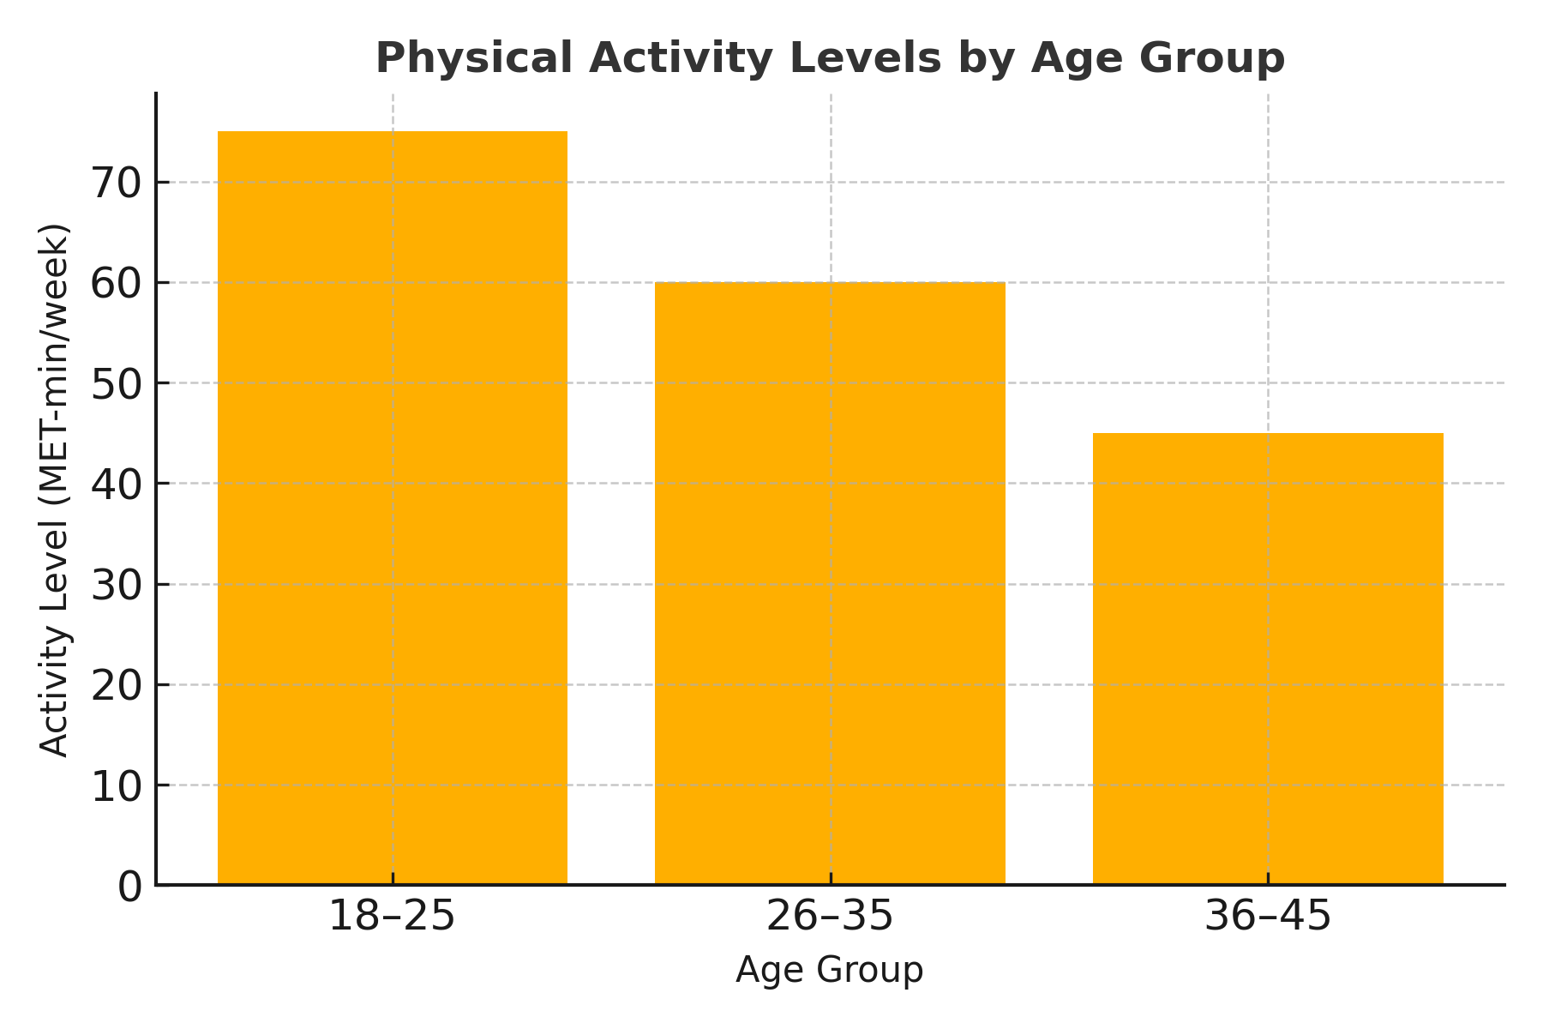
The discussion section serves several key purposes: it should directly address the research problem, provide a thoughtful interpretation of the findings, and relate these findings to existing literature and theoretical frameworks. Where relevant, it may propose the development of a new theory or refinement of an existing one. Use straightforward numbering (e.g., 1, 2, 3) without hyphens or composite numbering formats. Figures and tables should be placed either at the beginning or end of a page to maintain clarity and consistency in presentation (Source & Source, 2019; Source et al., 2018).

4. Conclusion

This section should provide a clear and concise summary of the study’s findings. Conclusions must be based on the results and highlight key insights or implications of the study. Recommendations should emerge logically from the findings and suggest specific, actionable steps. These may include practical applications, policy suggestions, or directions for future research. Indicate the intended audience or beneficiaries of the recommendations. This section should be written in cohesive essay form—not as a numbered list.

Acknowledgment

State the name of the funding agency or sponsoring institution, if applicable. Additionally, recognize individuals who contributed meaningfully to the study or manuscript but do not meet the criteria for authorship.

References
(APA 7th edition format – not included in word count)
Include only key references cited in the text. Use hanging indent formatting.

Format and Layout (APA Style Guidelines)

Manuscripts must be prepared on A4-sized paper (8.26 × 11.69 inches or 21 × 29.7 cm), with the following margins:
- Top: 1 inch (2.54 cm)
- Bottom: 0.8 inch (2.03 cm)
- Left and Right: 1 inch (2.54 cm)
Please double-check margin settings even when using this template, as local system defaults may override them.
Use Cambria, 11-point font, and double spacing throughout the document, in accordance with APA 7th edition guidelines. All text should be left-aligned and justified.
Apply boldface for headings (Level 1 and 2), and do not underline or italicize headings unless stylistically necessary. The title, author name(s), and affiliations should be centered on the first page only.
Begin each new paragraph with a 0.5 inch (1.27 cm) indent, but do not indent the abstract itself.

