**13th ASTHRDP Graduate Scholars’ Conference**

**“Advancing Climate Action and Environmental Stewardship for the Well-being of Every Filipino”**

September 18-19, 2024

Cagayan De Oro City, Misamis Oriental

| Name: | JUAN P. DELA CRUZ | | | | | | | Sex: | ☒ Male ☐ Female |
| --- | --- | --- | --- | --- | --- | --- | --- | --- | --- |
| Program of Study: | | | | ☒ PhD ☐ MS | | Area of Specialization: | | | PHYSICS |
| University: | | MINDANAO STATE UNIVERSITY-ILIGAN INSTITUTE OF TECHNOLOGY | | | | | | | |
| Year of Award: | | | 2022 | | Research Category: | | CATEGORY 3 | | |

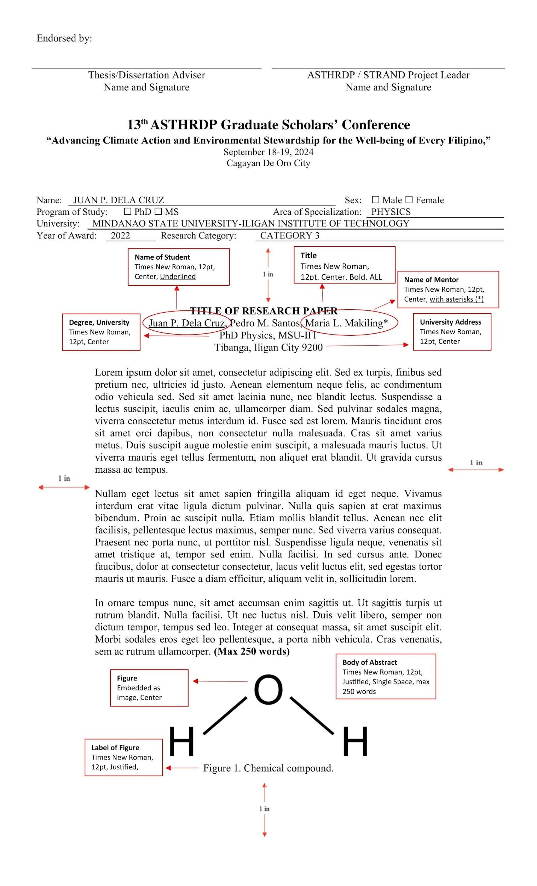

| Endorsed by: |  |  |
| --- | --- | --- |
|  |  |  |
| Thesis/Dissertation Adviser  Name and Signature |  | ASTHRDP / STRAND Project Leader  Name and Signature |
|  |  |  |

**13th ASTHRDP Graduate Scholars’ Conference**

**“Advancing Climate Action and Environmental Stewardship for the Well-being of Every Filipino,”**

September 18-19, 2024

Cagayan De Oro City, Misamis Oriental

| Name: | JUAN P. DELA CRUZ | | | | | | | Sex: | ☐ Male ☐ Female |
| --- | --- | --- | --- | --- | --- | --- | --- | --- | --- |
| Program of Study: | | | | ☐ PhD ☐ MS | | Area of Specialization: | | | PHYSICS |
| University: | | MINDANAO STATE UNIVERSITY-ILIGAN INSTITUTE OF TECHNOLOGY | | | | | | | |
| Year of Award: | | | 2022 | | Research Category: | | CATEGORY 3 | | |

**TITLE OF RESEARCH PAPER**

Juan P. Dela Cruz, Pedro M. Santos, Maria L. Makiling*

PhD Physics, MSU-IIT

Tibanga, Iligan City 9200

Lorem ipsum dolor sit amet, consectetur adipiscing elit. Sed ex turpis, finibus sed pretium nec, ultricies id justo. Aenean elementum neque felis, ac condimentum odio vehicula sed. Sed sit amet lacinia nunc, nec blandit lectus. Suspendisse a lectus suscipit, iaculis enim ac, ullamcorper diam. Sed pulvinar sodales magna, viverra consectetur metus interdum id. Fusce sed est lorem. Mauris tincidunt eros sit amet orci dapibus, non consectetur nulla malesuada. Cras sit amet varius metus. Duis suscipit augue molestie enim suscipit, a malesuada mauris luctus. Ut viverra mauris eget tellus fermentum, non aliquet erat blandit. Ut gravida cursus massa ac tempus.

Nullam eget lectus sit amet sapien fringilla aliquam id eget neque. Vivamus interdum erat vitae ligula dictum pulvinar. Nulla quis sapien at erat maximus bibendum. Proin ac suscipit nulla. Etiam mollis blandit tellus. Aenean nec elit facilisis, pellentesque lectus maximus, semper nunc. Sed viverra varius consequat. Praesent nec porta nunc, ut porttitor nisl. Suspendisse ligula neque, venenatis sit amet tristique at, tempor sed enim. Nulla facilisi. In sed cursus ante. Donec faucibus, dolor at consectetur consectetur, lacus velit luctus elit, sed egestas tortor mauris ut mauris. Fusce a diam efficitur, aliquam velit in, sollicitudin lorem.

In ornare tempus nunc, sit amet accumsan enim sagittis ut. Ut sagittis turpis ut rutrum blandit. Nulla facilisi. Ut nec luctus nisl. Duis velit libero, semper non dictum tempor, tempus sed leo. Integer at consequat massa, sit amet suscipit elit. Morbi sodales eros eget leo pellentesque, a porta nibh vehicula. Cras venenatis, sem ac rutrum ullamcorper. **(Max 250 words)**

Figure 1. Chemical compound.

| Endorsed by: |  |  |
| --- | --- | --- |
|  |  |  |
| Thesis/Dissertation Adviser  Name and Signature |  | ASTHRDP / STRAND Project Leader  Name and Signature |